**Lab 01**

**21k-3881**

**Basic concept:**

**Task 1**

import java.util.*;  
public class t1 {  
 public static void main(String[] args) {  
 Scanner x=new Scanner(System.*in*);  
 System.*out*.println("Enter 1st digit");  
 int p=x.nextInt();  
 System.*out*.println("enter 2nd digit");  
 int q=x.nextInt();  
 int r=p+q;  
 System.*out*.println("sum=" +r);  
 }  
}

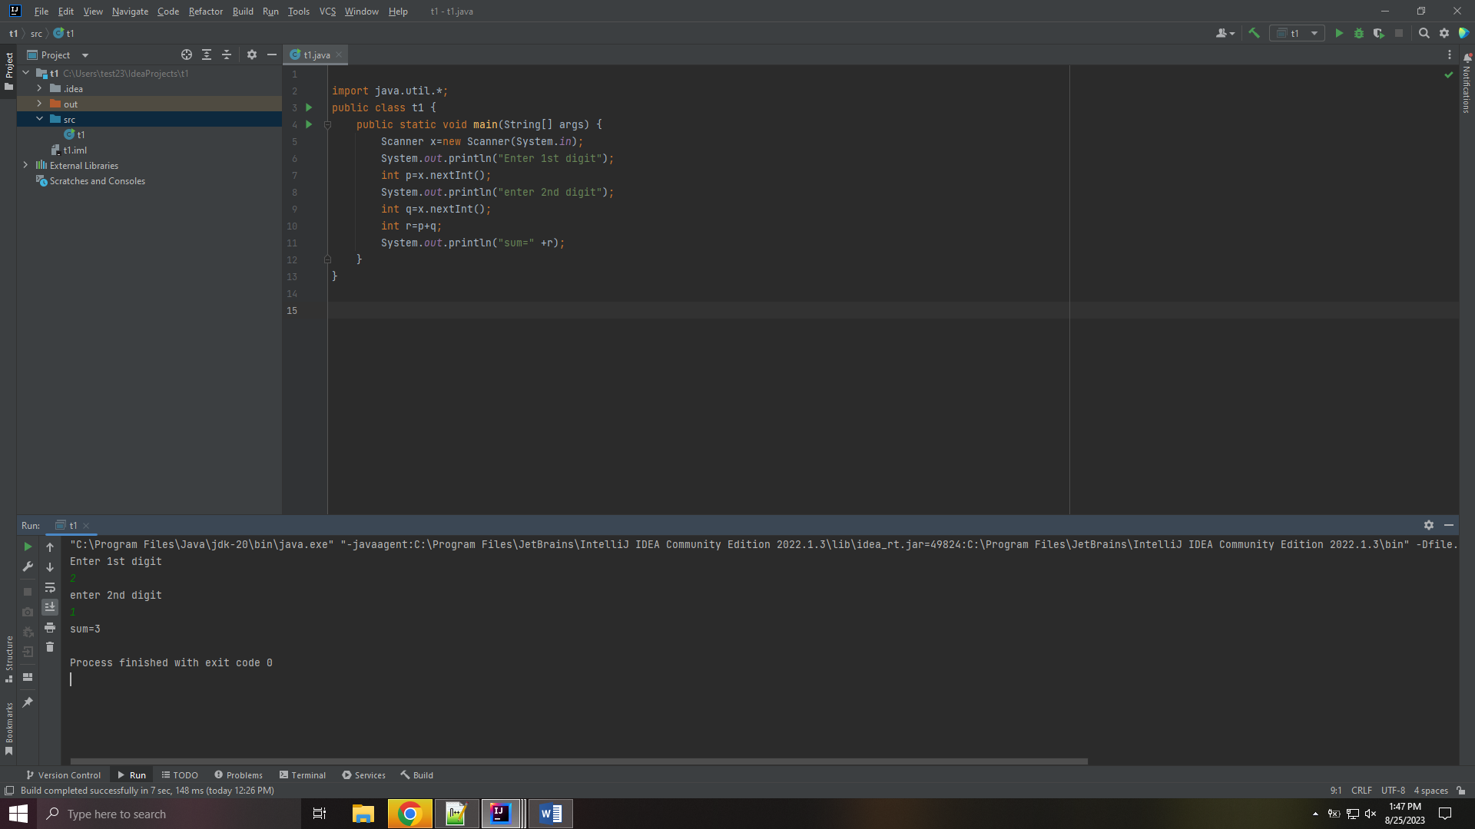

**Task 02:**

import java.util.*;  
public class t2 {  
 public static void main(String[] args) {  
 Scanner x=new Scanner(System.*in*);  
 System.*out*.println("input name :");  
 String n=x.nextLine();  
 System.*out*.println("Hello "+n);  
  
 }  
  
}

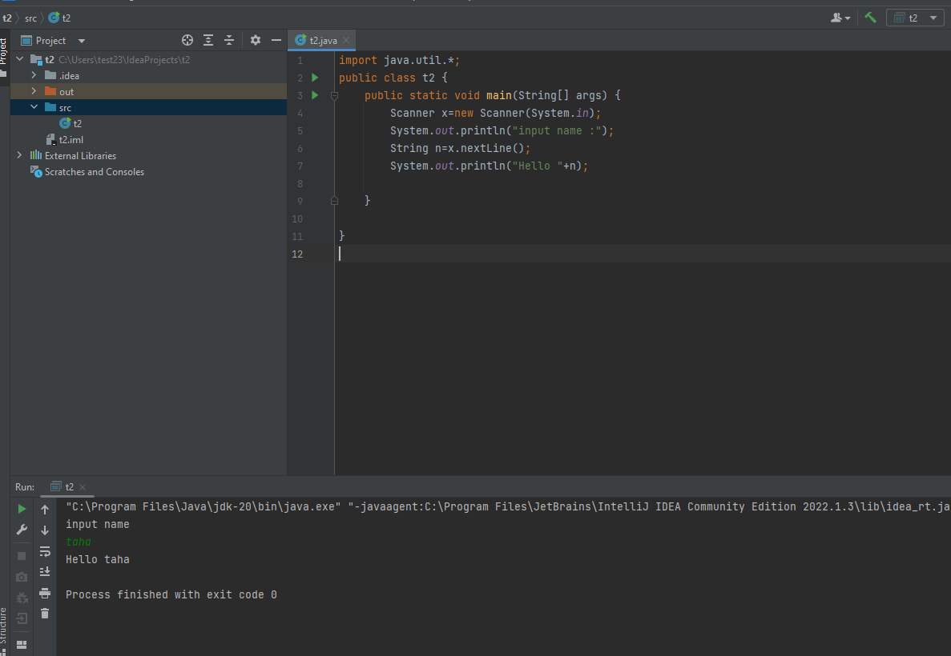

**Task 03:**

import java.util.*;  
public class t3{  
 public static void main(String[] args) {  
 Scanner x=new Scanner(System.*in*);  
 System.*out*.println("input digit :" );  
 int s;  
 s=x.nextInt();  
 if(s%2==0) {  
 System.*out*.println("Even");  
 }  
 else {  
 System.*out*.println("Odd");  
 }  
 }  
  
}

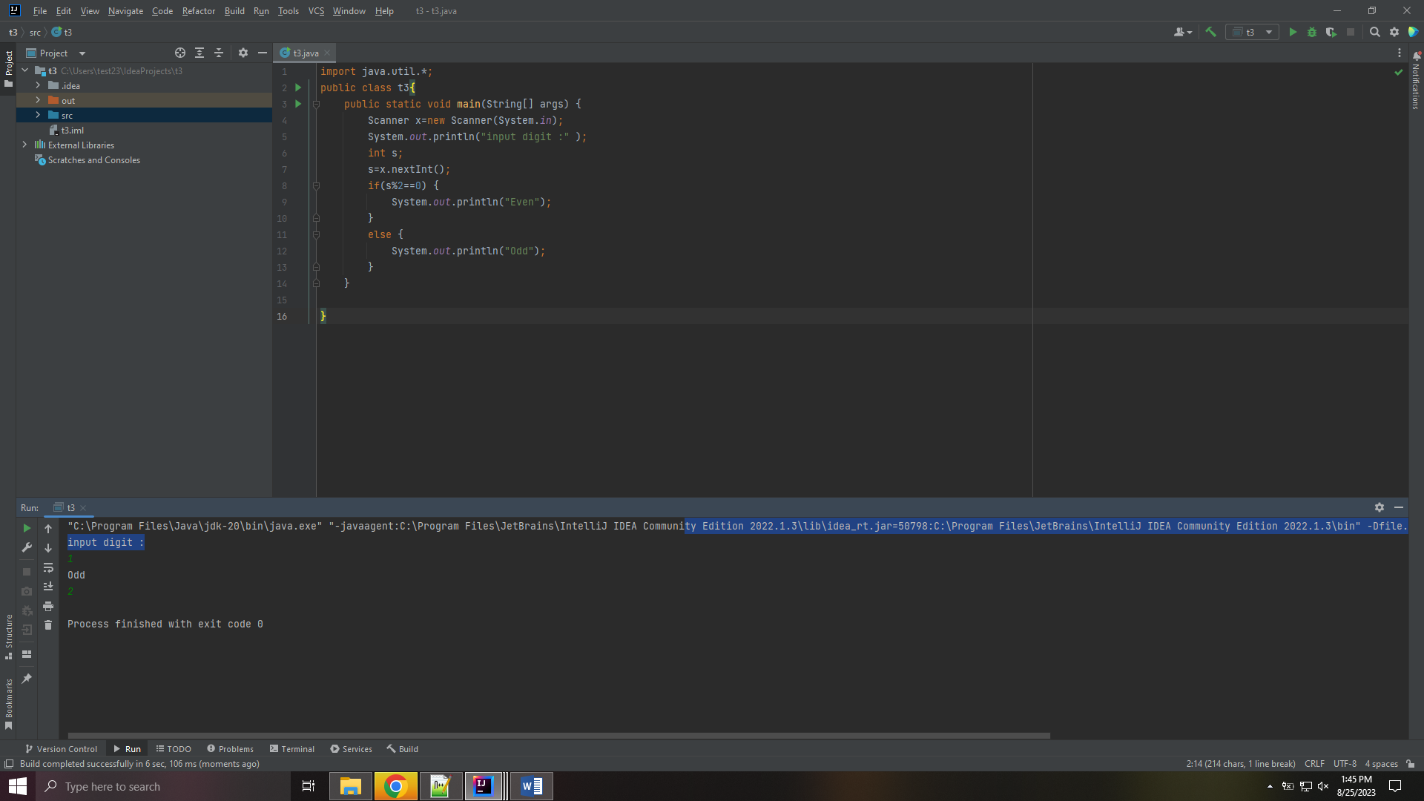

**OOP concept:**

**Task 01:**

import java.util.*;  
class rect{  
 int w,h;  
 public rect(int w,int h) {  
 this.w=w;  
 this.h=h; }  
 public int parameter(){  
 int p=this.w+this.h;  
 return p;  
 }  
 public int area(){  
 int a=2*this.w*this.h;  
 return a;  
 }  
}  
public class t4{  
public static void main(String args[]){  
 Scanner x=new Scanner(System.*in*);  
 int h,w;  
 System.*out*.print("input triangle width = ");  
 w=x.nextInt();  
 System.*out*.print("input triangle height = ");  
 h=x.nextInt();  
 rect r=new rect(h,w);  
 System.*out*.println("Area of triangle = "+r.area());  
 System.*out*.println("Paramter of triangle = "+ r.parameter());  
 }  
}

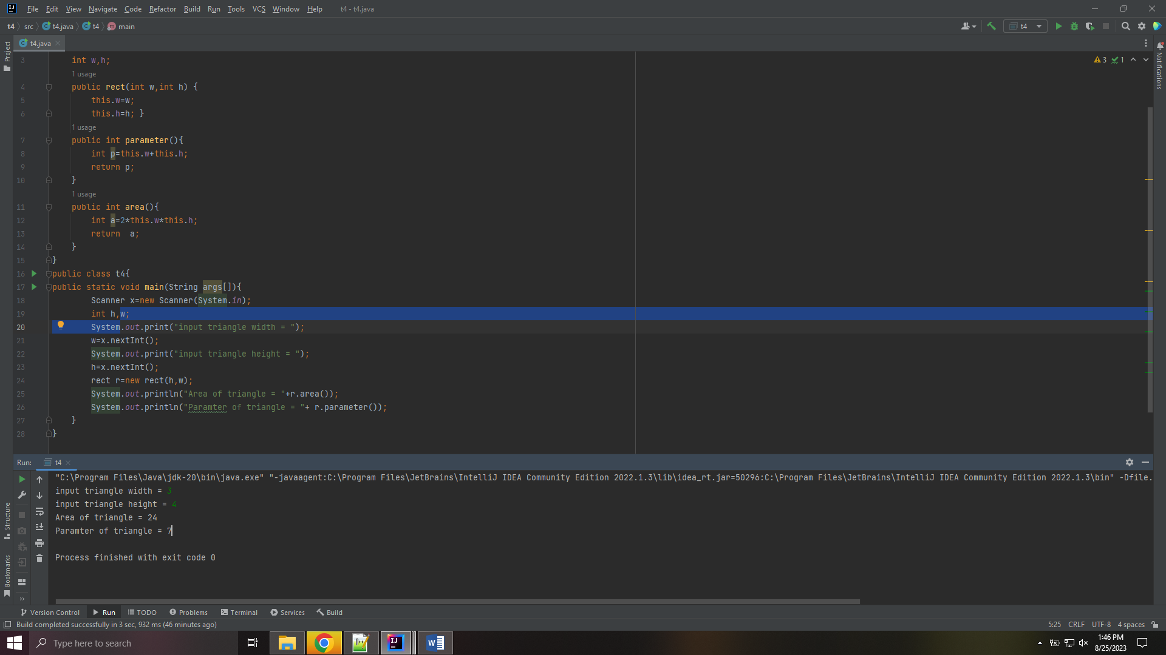

**Task 02:**

import java.util.*;  
class bank{  
 int amu=1500;  
 bank(int acc){  
 this.amu=acc;}  
 bank(){}  
 public void print(){  
 System.*out*.println("The total balance of your account is = "+amu); }  
}  
class account extends bank{  
 public void check_balance(){  
 System.*out*.println("you have cash in your account = "+amu); }  
}  
class cash_transaction extends bank{  
 int bal;  
 void cash_deposit(){  
 Scanner x=new Scanner(System.*in*);  
 System.*out*.print("how much amount would you like to deposite =");  
 int d=x.nextInt();  
 amu=amu+d; }  
 void cash_withdraw(){  
 Scanner x=new Scanner(System.*in*);  
 System.*out*.print("how much amount would you like to withdraw = ");  
 int w=x.nextInt();  
 amu=amu-w; }  
}  
public class t5 {  
 public static void main(String[] args) {  
 Scanner x = new Scanner(System.*in*);  
 account a = new account();  
 cash_transaction t = new cash_transaction();  
 for (int i = 0; i < 3; i++) {  
 System.*out*.println("What would you like do from the following :");  
 System.*out*.println("1) Check Balance of account \n2) Deposite amount \n3) Withdraw amount");  
 int select = x.nextInt();  
 if (select == 1) {  
 a.check_balance();  
 } else if (select == 2) {  
 a.check_balance();  
 t.cash_deposit();  
 t.print();  
 } else if (select == 3) {  
 a.check_balance();  
 t.cash_withdraw();  
 t.print();  
 }  
 System.*out*.println();  
 }  
 }  
}

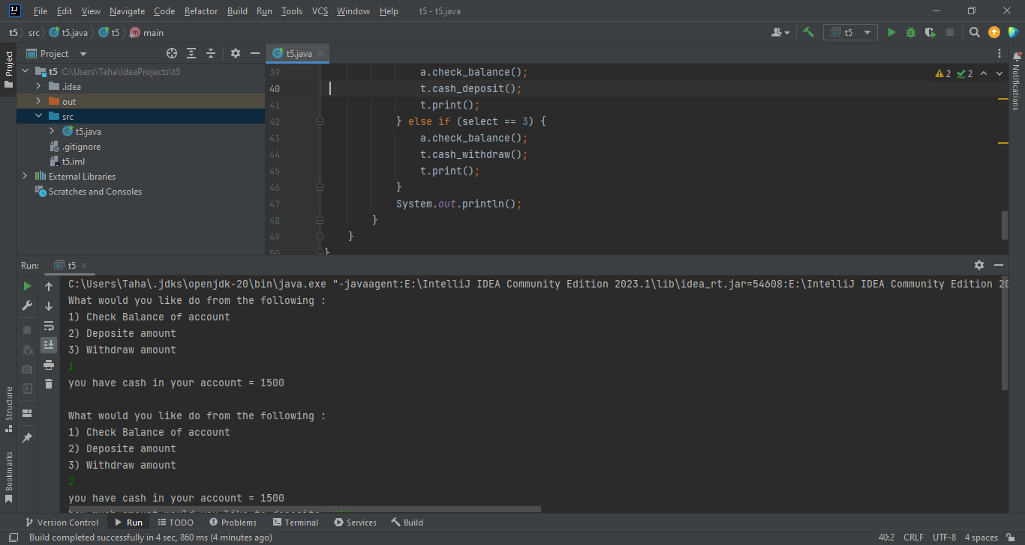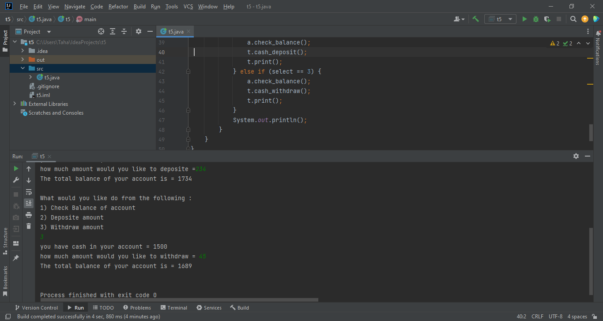

**Task 03:**

import java.util.*;  
class vehicle{  
 String n,m;  
 float dis,sp,t;  
 vehicle(String n,String m,float dis,float t){  
 this.n=n;  
 this.m=m;  
 this.dis=dis;  
 this.t=t; }  
 public void max_speed(){  
 sp=dis/t; }  
 public void print(){  
 System.*out*.println("Name: "+n);  
 System.*out*.println("Model: "+m);  
 System.*out*.println("Speed: "+sp); }  
}  
class bicycle extends vehicle{  
 bicycle(String n,String m,float dis,float t){  
 super(n,m,dis,t); }  
}  
class car extends vehicle{  
 car(String n,String m,float dis,float t){  
 super(n,m,dis,t); }  
}  
public class t6 {  
 public static void main(String[] args) {  
 Scanner x = new Scanner(System.*in*);  
 for (int i = 0; i < 2; i++) {  
 System.*out*.println("what would you like to choose :");  
 System.*out*.println("1) bicycle \n2) car ");  
 int choose = x.nextInt();  
 if (choose == 1) {  
 System.*out*.println("bicycle");  
 bicycle c = new bicycle("suzuki", "2020", 150, 2.5f);  
 c.max_speed();  
 c.print();  
 } else if (choose == 2) {  
 System.*out*.println("car");  
 car r = new car("kia", "2019", 24000, 6.5f);  
 r.max_speed();  
 r.print();  
 }  
 }  
 }  
}

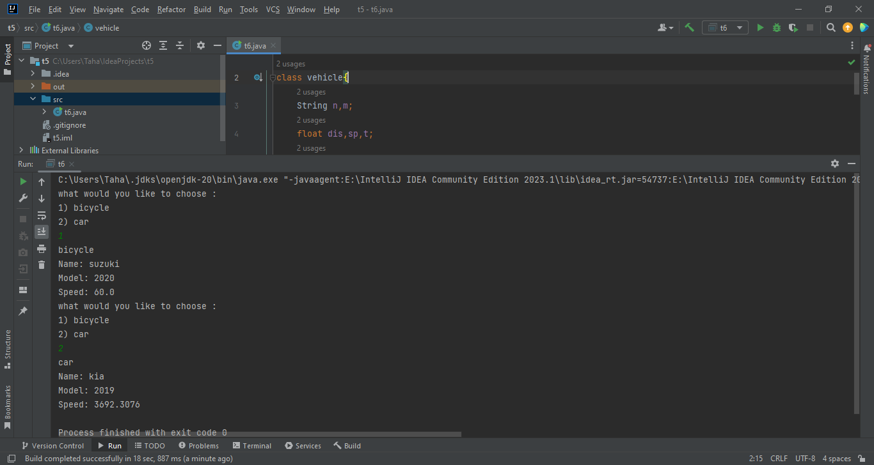

**Inheritance and Polymorphism:**

**Task 01:**

import java.util.*;  
class vehicle{  
 String n,m;  
 float dis,t,sp;  
 vehicle(String n, String m,float dis,float t){  
 this.n=n;  
 this.m=m;  
 this.dis=dis;  
 this.t=t; }  
 void max_speed(){  
 sp=dis/t; }  
 void print(){  
 System.*out*.println("Name: "+n);  
 System.*out*.println("Modle: "+m);  
 System.*out*.println("Distance: "+dis);  
 System.*out*.println("Speed: "+sp); }  
}  
class sports_car extends vehicle{  
 sports_car(String n, String m,float dis,float t){  
 super(n,m,dis,t); }  
}  
class mountain_bike extends vehicle{  
 mountain_bike(String n,String m,float dis,float t){  
 super(n,m,dis,t); }  
}  
public class t7 {  
 public static void main(String[] args) {  
 Scanner x = new Scanner(System.*in*);  
 for (int i = 0; i < 2; i++) {  
 System.*out*.println("What would you like to choose :");  
 System.*out*.println("1) Mountain bike ==== 2) sports car ");  
 int choose = x.nextInt();  
 if (choose == 1) {  
 System.*out*.println("Mountain_bike");  
 mountain_bike m = new mountain_bike("honda", "2019", 1200, 3.5f);  
 m.max_speed();  
 m.print();  
 } else if (choose == 2) {  
 System.*out*.println("Sports_car");  
 sports_car s = new sports_car("Thar", "2022", 23000, 5.5f);  
 s.max_speed();  
 s.print();  
 }  
 }  
 }  
}

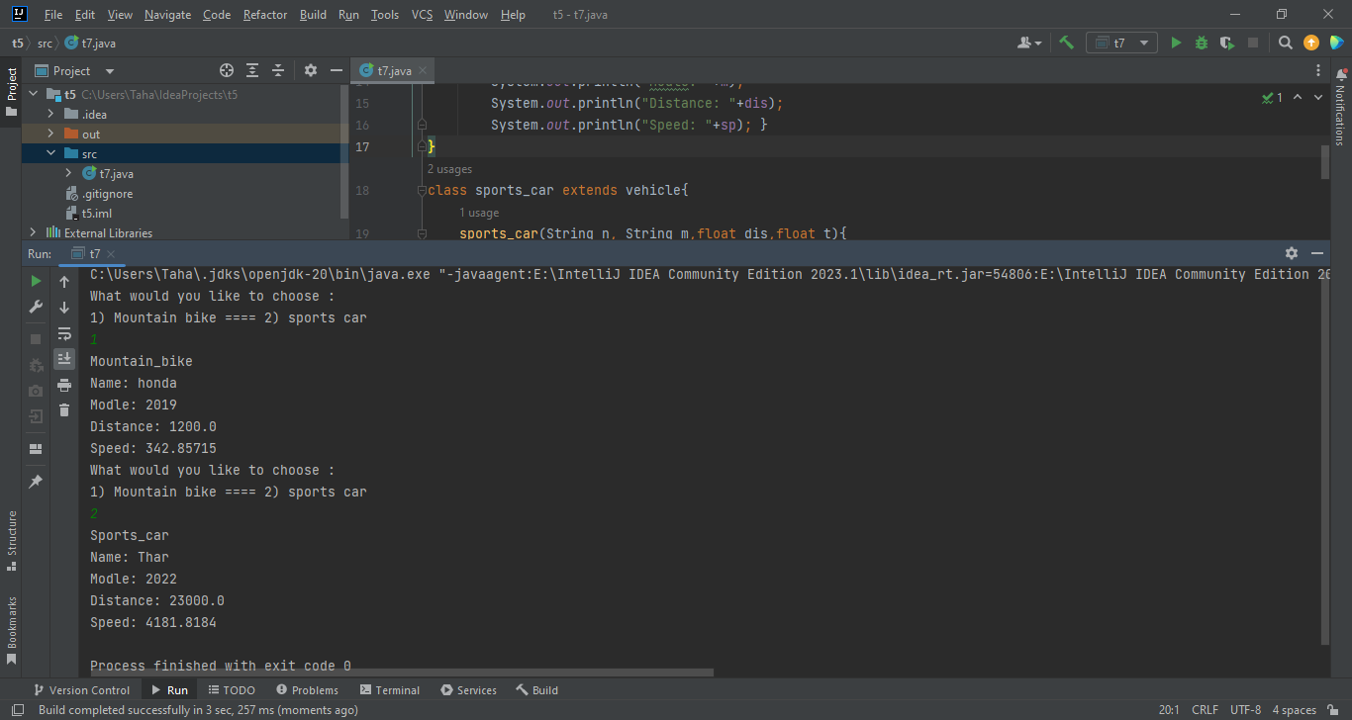

**Task 02:**

class shape{  
 float a;  
 public void print(){  
 System.*out*.println(a);}  
}  
class triangle extends shape{  
 int b,h;  
 triangle(int b,int h){  
 this.b=b;  
 this.h=h; }  
 public void area(){  
 a=(b*h)/2; }  
}  
class square extends shape{  
 int s;  
 square(int s){  
 this.s=s; }  
 public void area(){  
 a=s*s; }  
}  
class cricle extends shape{  
 float r,p=3.14f;  
 cricle(int r){  
 this.r=r; }  
 public void area(){  
 a=p*(r*r); }  
}  
public class t8{  
 public static void main(String[] args) {  
 System.*out*.print("The area of Triangle is = ");  
 triangle tri=new triangle(35,20 );  
 tri.area();  
 tri.print();  
 System.*out*.print("The area of Square is = ");  
 square sq=new square(6);  
 sq.area();  
 sq.print();  
 System.*out*.print("The area of circle is = ");  
 cricle cir=new cricle(15);  
 cir.area();  
 cir.print(); }  
}

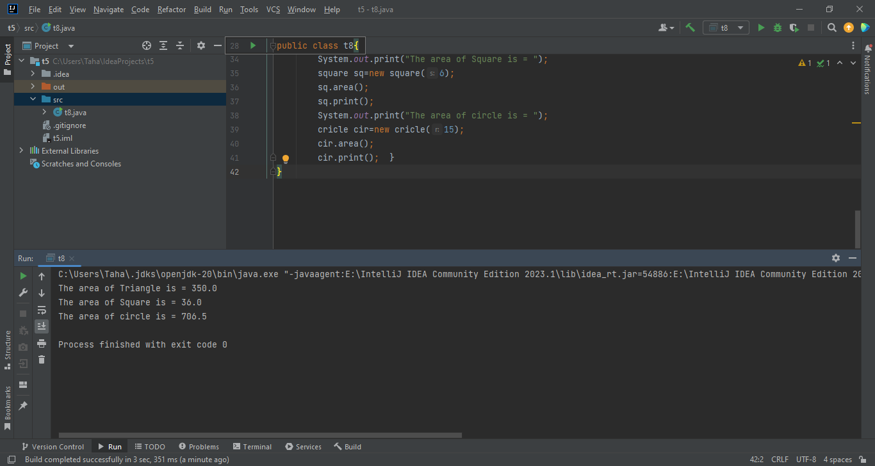

**Task 03:**

class vegetable{  
 public void print(){  
 System.*out*.println("this is vegetable"); }  
}  
class potato extends vegetable{  
 @Override  
 public void print(){  
 System.*out*.println("this is potato"); }  
}  
class cabbage extends vegetable{  
 @Override  
 public void print(){  
 System.*out*.println("this is cabbage"); }  
}  
public class t9 {  
 public static void main(String[] args) {  
 vegetable veg=new vegetable();  
 veg.print();  
 potato po=new potato();  
 po.print();  
 cabbage cab=new cabbage();  
 cab.print(); }  
}

